# Introduction

The Maritime industry is tapping into the world of automation and digitalization. The automation level of vessels is increasing rapidly. Vessels are getting connected to the shore by different means. Operational data is becoming available and enriched with other data like design data, weather data and maintenance data. These technologies boost the development of autonomous and unmanned vessel designs [Blanke et al. (2017)]. At the same time is the Maritime Industry faces challenges when it comes to crewing and safety [Cappelle et al. (2018)]. Also increasing competition makes it hard to realise healthy margins. These trends trigger Maritime Industry to embrace autonomous sailing technologies to secure a healthy future.

These business developments are reflected in the significant amount of research and development projects [SMASH (2017)] [Eriksen (2017)] [MUNIN (2016)] [Sames (2017)] [Rolls-Royce (2015)] [Waterborne (2016)]. Each of these projects tackle one or more challenges in the development of autonomous sailing. However, the challenge of communication between unmanned and manned vessels has not been tackled [Saarni et al. (2018)]. In chapter 1, the challenges and corresponding projects are discussed. Currently no solutions are available. However, this is necessary to ensure the safety of all vessels: manned, unmanned, remote, automated and autonomous.

This report presents the results of my thesis on communication between unmanned autonomous sailing vessels and manned vessels. It presents a design philosophy which has been translated in a methodology for handling communication which is eventually translated in protocols which are derived based on theory and validated by means of simulations.

#### Context

In many situations the Convention on the International Regulations for Preventing Collisions at Sea (COLREGs) is sufficient to determine the intentions of other vessels [IMO (1972)]. These can be seen as ship separation rules, which guide all vessels to make early and correct alterations to their course. It will take more time to assess the situation when using VHF. Meaning less time to act limiting the possible strategies. These rules do also apply to autonomous ships, and thus can be used when manned and unmanned vessels meet. Examples are to stay on starboard side of the shipping lane, and not to cross other ships with small relative angle. When these rules are or cannot be applied, communication is necessary. When this communication doesn’t happen correctly, accidents will occur (appendix C). Thereby are there also situations in which regulations are contradictory, such as the accident between Artadi and St-Germain as described in appendix C.2. This occurs more often in complex situations, such as a harbor approach.

The risks when COLREGs are not sufficient can be mitigated by taking decisions, well in advance. What ‘well in advance’ means, depends on the manoeuvrability of a vessel. A cargo vessel will follow common routes, while a small tug boat might move around much more. The latter results in more false positives on potential collisions with other vessels, when using the equal safety domain and evaluation system. The manoeuvrability means that it is necessary to think ahead several minutes with a large ship, while this is much shorter for a small tug boat. This time-domain for decision making depends not only on the ship characteristics, but also on the waterway characteristics. In chapter 2 this will be discussed in more detail, examples are the depth, traffic separation schemes and harbor entrances.

If it is not possible to take decision well in advance, it is often due to a lack of information. This can be solved by communication. Communication between manned vessels happens with different systems. Most important is communication via VHF, thereby is information from the AIS used to identify vessels. This information can also help to determine the intentions of the vessel, based on the type of vessel or destination. The used protocols for these systems are discussed in appendix A

#### Design philosophy

We developed a strategy to cope with the challenge of communication between manned and unmanned vessels, without introducing new systems to the bridge of manned vessels. At first we will try to avoid the need for communication, by ensuring safe navigation i.e. enough distance between passing ships. Due to circumstances this might not be possible and communication is required. For the communication between manned and unmanned vessels a new communication protocol must be developed. The strategy for this protocol can be used as a foundation to build a system for decision making that ensures safe operation for both manned and unmanned vessels. The development of this strategy and protocol required multiple steps.

First insights have been acquired on the decision model for safe navigation, to determine the relevant factors to make a decision. The next step is to determine how these factors influence the decision process. This can also be used to determine the critical situations i.e. showing when communication to navigate correctly is required. This leaves specific situations for which a communication protocol must be developed. Using the situated Cognitive Engineering (sCE) method, the operational requirements, relevant human factors and envisioned protocol can be defined. The current state of the maritime industry is taken into account.

*CONTENTS* 3

#### Research questions

The report covers includes two different research domains in more detail Maritime Technology and Computer Science. The part on maritime technology focuses on the situation where manoeuvring is just enough. The computer science part focuses on the development of the communication protocol. The following research questions will be answered for these domains:

*How do ship manoeuvrability characteristics influence the domain for decision making, to ensure that the chosen strategy will result in a passing distance that does not require communication?*

*Will a protocol based on existing maritime systems and communication protocols be sufficient to ensure safe navigation, while manned and unmanned vessels encounter each other?*

#### Report structure

This research report contains three parts to cover the challenge of communication between manned and unmanned vessels. Part I describes the relevant context of autonomous shipping. This context and a decision-model describes why communication is a challenge and how this challenge can be tackled.

Part II describes how communication can be avoided. It is important first to determine when communication is necessary. This is especially the case in critical situations i.e. deviating from the standard safety guidelines. These situations are tested in a simulation environment. This simulation describes the time-domain for decision making to ensure safe operation. This determines the moments decisions must be made in critical situations. These situations are simulated, using a validated manoeuvring model in the simulation environment. Thereby is also evaluated whether the time-domain can be improved to ensure communication is needed in fewer situations.

Part III will focus on the critical situations where communication is a must. Currently no communication protocol is available between manned and unmanned vessels. Communication is necessary when there is a lack of trust, missing information or the time-domain for decision making becomes critical. To ensure a fest implementation of the communication protocol between manned and unmanned vessels, it will be based on existing systems and protocols. The objective is to validate whether it is possible to define a protocol using the situated Cognitive Engineering (sCE) method that will be accepted by seafarers.

**Part I**

**The problem of communication for autonomous vessels**

*It is impossible for a man to learn what he thinks he already knows.*

– Epictetus [Adamson (2003)]

5

7

Safety at sea has been a relevant topic for as long as ships exist. Nowadays communication has become very important to ensure the safety of all ships. Communication can be all forms of sharing information. Before the invention of radio communication, ships literally lost all connection with the shore and other ships when setting sail. Flags were used when ships were close to others ships or to the shore. This form of communication was not complete as it only gave limited insight in the intentions of other vessels for example. To ensure the safety of ships, they agreed how to act in specific situations. These agreements became the foundation of the regulations as written down in the Convention on the International Regulations for Preventing Collisions at Sea (COLREGs) [IMO (1972)].

New technologies led to new ways for communication, such as radio communication. This led subsequently to safer operation. This works very well between manned vessels, as human can work well with limited unstructured information compared to computers. For unmanned ships this is however a challenge. With autonomous ships getting closer, a solution must be found. Also because new technologies have led to more complex situations and ships get bigger and perform more complex operations. Due to the limitations of unmanned vessels when it comes to communication, it does become even more important to make the right decisions well in advance. This to avoid critical situations and enable those ships to share the right information at the right time.

There are many projects working on unmanned autonomous ships. Chapter 1 starts to describe why steps are taken towards autonomous and unmanned shipping, including the economic and social incentives. Followed by a description of projects, showing the technological push factor. This will give more insight into the challenges as seen by others relevant for the introduction of unmanned vessels and the communication challenge between manned and unmanned vessels. A distinction is made between the more exploratory projects aimed to form a vision of the future, and the applied projects aimed to develop prototypes on the shorter term. Chapter 2 connects these challenges to the decision model for ships. This illustrates that the need for communication depends on the steps taken in the decision process i.e. that it might be possible to avoid communication and ensure safe operation.

8

# *|* Steps into the future

This research focused on improving safety at sea by mitigating the risk that comes with communication between manned and unmanned vessels. This subject was not yet in the scope of the major projects. This chapter the reasoning for the transition and shows what the social or economic incentives are. Followed by the technological drivers in the form of projects that work on autonomous shipping. Additionally, is shown how these projects address the problem of communication to evidence that the challenge of communication between manned and unmanned vessels is less explored and deserves to be explored.

## Why autonomous and unmanned shipping

Due to digitalization, ships will become more sophisticated. More data is generated by sensors, connectivity will improve and new ways to visualize data become available. This enables ships to continuously communicate with managers and traffic controllers. Initially this can be used to analyze data and improve advises based on expected weather, fuel consumption and arrivals at bottlenecks like ports and bridges. But further ahead this might result in unmanned vessels that might be operated remotely. In parallel there is the transition where people are taken out the chain of commands, which will result in automated or completely autonomous vessels. The main arguments heard for the transition towards autonomous or unmanned ships [Saarni et al. (2018)]:

* + - *Improved safety*, as most accidents are caused by human errors. Thereby will there be less crew at the ship, thus less crew is at risk when an accident occurs.
    - *Lower cost*, as insurance goes down due to improved safety. Thereby is manning a large portion of total cost. With more automation, less crew is needed, although they need to be educated better.
    - *Higher productivity*, as the utilization rate of ships can be improved when data is used more effective. Thereby comes that computers don’t have to work in shifts, go home or take breaks.
    - *More comfort and attractive industry*, as people can have more regular hours to work and do not have to be away for many weeks when working remote.

The maritime trade volumes are expected to increase in the future and accordingly the numbers of ships needed to transport the freight will grow, as will the number of seamen required to operate the vessels. At the same time European shipping faces a lack of seafaring

9

personnel already today [Cahoon et al. (2014)]. An often mentioned reason for this lies in the unattractiveness of seagoing professions, especially for youngsters. To some extend this is caused by seafaring’s inherent problem of lacking family friendliness and the high degree of isolation from social life that comes along with working on a seagoing ship. The current trend towards slower sailing speeds justified by ecologic and economic considerations increases the length of the ship’s voyage and extends the time seamen spend on sea even further [Finnsg˚ard et al. (2018)].

Here, the unmanned autonomous vessel represents a way out of the impasse of a shortage in the supply of seafarer due to the job’s perceived unattractiveness and a growing demand for seafarer caused by slow steaming and increasing transport volumes. This could reduce the expected pressure on the labour market for seafarer as it would enable, at least partly, to reduce the labour intensity of ship operation. Routine tasks on board will be automated and only the demanding but interesting navigational and technical jobs transferred from ship to a shore side operation centre. This will make “seafaring” jobs more attractive and family friendly than today. Furthermore, economic and environmental benefits are also expected when implementing unmanned shipping. [MUNIN (2016)]

In the next sections are different projects around the world discussed that work on the transition towards autonomous or unmanned vessel. The projects are working on various levels of automation. These different levels are shown in figure 1.1a. This illustrates that the higher the level of automation, the automated systems become more in control. The blue boxes show when a human is in control, while the orange boxes show when automated systems are responsible for the mentioned activity. Beside these levels of automation, also different kind of automation are applicable, each with its own challenges. The types are shown in 1.1b.

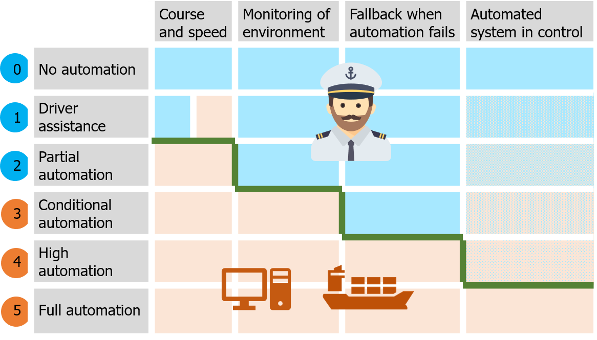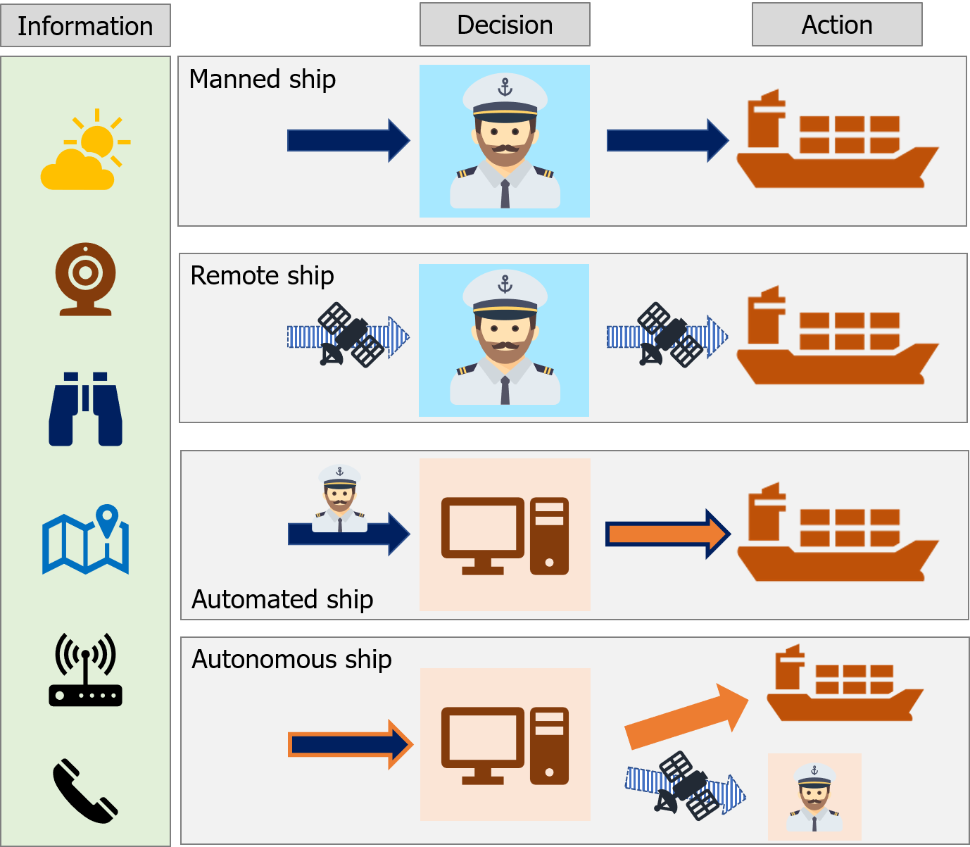

(a) Levels of automation (b) Types of automation on ships

Figure 1.1: Steps from manned to autonomous ships

## Projects

The vision on autonomous ships is not new, as it already occurred in a book on future ship concepts in 1973. The EU-funded research project MUNIN triggered the renewed interest for autonomous shipping [Saarni et al. (2018)]. The name is an abbreviation for Maritime Unmanned Navigation through Intelligence in Networks and originated from WATERBORNE. An initiative from the EU and Maritime Industries Forum, supporting cooperation and exchange of knowledge between stakeholders within the deep and short sea shipping industry. They did an initial research between 2013 and 2016 that focused on different elements of the autonomous concepts (figure 1.2):

* + - The development of an IT architecture.
    - Analysis tasks performed on today’s bridge and how this will be on an autonomous bridge.
    - Examining the tasks in relation to a vessel’s technical system and developing a concept for autonomous operation of the engine room.
    - Define the processes in a shoreside operation center, required to enable a remote control of the vessel.

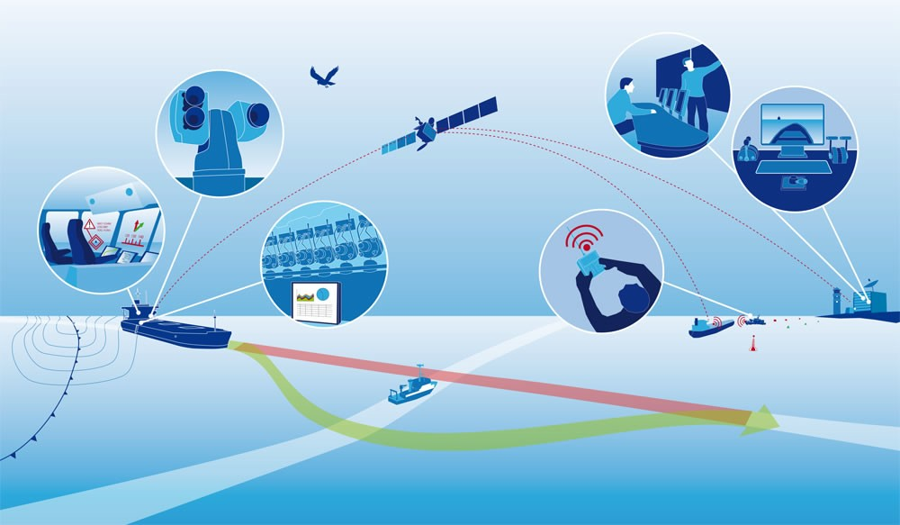

Figure 1.2: Illustration of MUNIN vision

They also considered the feasibility of the developed solution, including legal and liability barriers for unmanned vessels. They concluded that unmanned vessels can contribute to the aim of a more sustainable maritime transport industry. Especially in Europe, shipping companies must deal with a demographic change within a highly competitive industry, while at the same time the rising ecological awareness exerts additional pressure on them. The autonomous ship represents a long-term and comprehensive solution to mitigate the challenges. It offers a potential solution to reduce operational expenses and reducing the environmental impact. A concept

was developed for a bulker vessel, enabling the consortium to do a financial analysis. Showing the viability but admitting the limited scope of the project [MUNIN (2016)]. They have showed the importance of developing a method to determine intentions of other vessels and systems that are needed. But they did not yet make the step towards developing such a method, which is the scope of this report.

### Exploratory projects

Different project worked on the vision about the future of shipping, often these projects have different phases in which the level of automation increases with every iteration. Examples of projects currently running all over the world are:

* + - * One Sea – Autonomous Maritime Ecosystem by DIMECC Ltd.
      * Advanced Autonomous Waterborne Applications
      * Unmanned Cargo Ship Development Alliance
      * ReVolt

Rolls-Royce Marine is involved in different projects, which are in some way follow-ups to the MUNIN project. The videos of the virtual bridge concept and the Electric Blue vessel have had many views, as this showed clearly their vision of how the shipping industry could look like in the future. Electric Blue is a concept ship, based on a standard 1000 TEU feeder and shown in figure 1.3. The ship is very adaptable, it can sail for example on both diesel and electricity. The modularity enables Electric Blue to adapt for specific routes and meet environmental requirements now, and in the future.

Keeping in mind that the way towards autonomous, will start with a virtual bridge, which is housed below the containers. Utilizing the opportunities for sensors during safe navigation. By using Radar, camera, IR camera, LIDAR and Automatic Identification System (AIS). The aim of this concept is to have partial autonomy by 2020, remote operation between 2025 and 2030, starting with a reduced passive crew on board. And be fully autonomous in 2035 [Wilson (2017)]. They pinpointed the control room, as the nerve centre of remote operations. Using an interactive environment with a screen for decision support and improving situation awareness with augmented reality. With these developments does their vision look very promising. However there have not yet been successful prototypes.

Since June 2017 is Rolls-Royce also involved in the unmanned cargo ship development alliance, which is initiated by Asian companies and classification bureaus. Their aim is to develop unmanned cargo ships with independent navigational capacity and make market promotion

so as to promote the development of intelligent shipping. The alliance would not only promote changes in the ship design and operation, but also facilitate the establishment of technology, regulation and standard system involved in unmanned cargo ships. Combined with the accumulation of rules and standards as well as the field of intelligent ship.

### Industry projects

Where the exploratory projects work on the vision and far future of autonomous. Are some companies working towards prototypes, often funded by customers of shipping companies. The Yara Birkeland is one of the projects ahead of the pack, already building and testing a 120 Twenty foot Equivalent Unit (TEU) container ship (figure 1.4). This vessel will initially operate as fully electric manned vessel, but plans are that it will sail autonomously in 2020. Operating between different Yara facilities in Norway, transporting fertilizers and raw materials. Meaning the path and quay are always the same, which reduces the amount of challenges. Kongsberg is responsible for the development and delivery of all key enabling technologies. Including the sensors and integration required for remote and autonomous operations, in addition to the electric drive, battery and propulsion control systems [Sames (2017)].

Other smaller projects are the development of Norwegian ferries, which are likely to start sailing automated from 2018, just like an automated shuttle service for offshore installations. A partly Dutch project is the Roboat, where a fleet of small pontoons will be used to solve problems on urban waterways. Such as transportation of people and goods or creating temporary dynamic floating structures like bridges and stages. Which is a collaboration between AMS Institute and MIT.

Where most of the previous projects were focussed around developing a vessel which has to operate in the current environment. Does the smart shipping challenge (SMASH) focus on combining technological developments within different parts of the inland shipping industry in the Netherlands, such as bridges and terminals. This will help to steer ships remotely, enable intelligent exchange of information and the optimization of waterway maintenance. Good examples are the new vessels from Nedcargo and the Gouwenaar 3. These vessels will be able to transport more containers, while reducing the fuel consumption. This will not only be acquired by improving the hull shape and machinery, but also by sailing smarter. For example by optimizing the speed, based on opening times for bridges and availability of the quay [SMASH (2017)].

A future project from the Netherlands is a joint industry project, under the name Sovereign. The research conducted on communication and decision making will support the final result

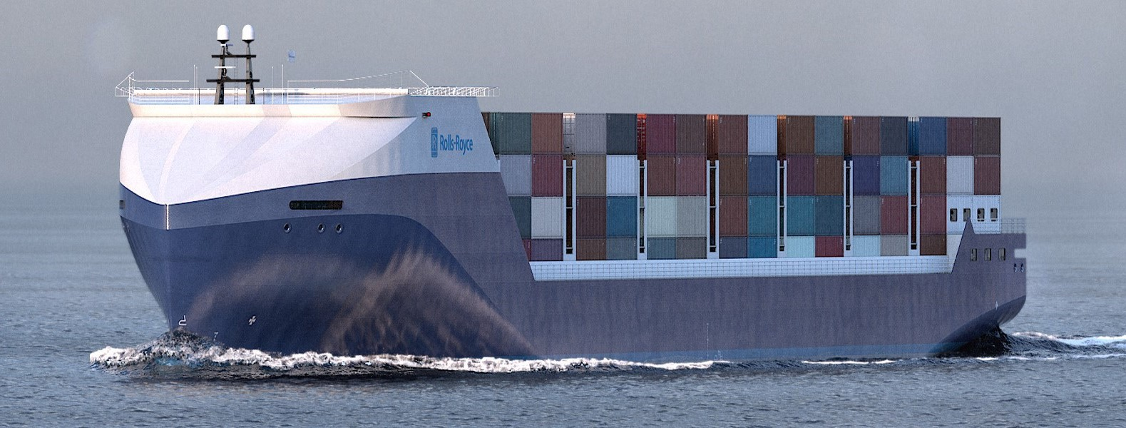

Figure 1.3: Render of Electric Blue

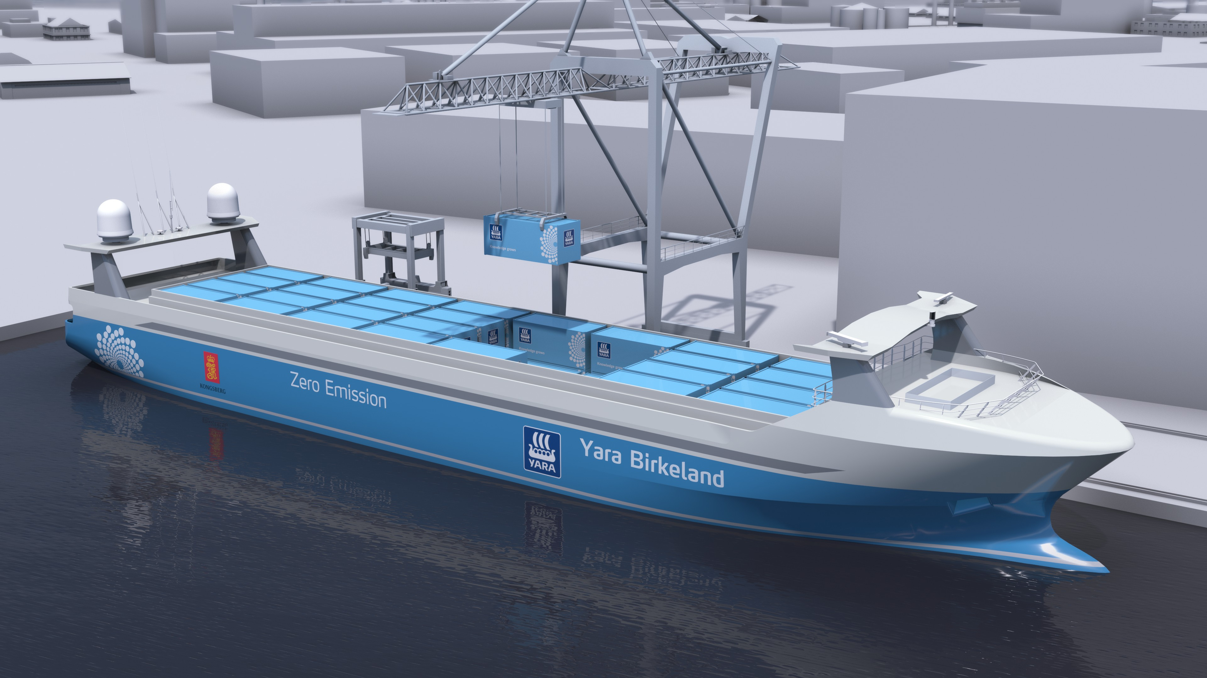

Figure 1.4: Render of Yara Birkeland

*1.3. STAKEHOLDERS* 15

of this project via Damen Shipyards and the Technical University of Delft. In this project did European companies, research institutes and the Technical University of Delft partner to develop a technology to deal with difficult environments and complex transport missions, within short sea and port traffic situations. Which is also applicable to other autonomous waterborne operations, such as inland waterways transport and coastal/inter-island short range ferry services. This should result in a ship for the shipping company Amasus.

Based on the above mentioned projects, are the most direct use cases: Local transport between factories and terminals and short sea shipping solutions. However there might be more in the future, such as the usage of tugs as extra actuator in dynamic positioning systems.

## Stakeholders

When these ships will sail, does not only dependent on the rate in which the technology can be developed. But there are also regulatory bodies, such as International Maritime Organization (IMO) and classification societies which need to incorporate autonomous vessels in their frameworks. The exploratory projects are very important, as this will help them to prioritize the codes for different ship types. These codes include information on autonomy levels and how to certify unmanned vessels.

Another groups of stakeholders are the shipbuilders, system integrators and suppliers for subsystems. These are responsible for the technological development. More and more shipyards try to get involved, to gain knowledge on the development process. Also are there the companies from other industries, which see opportunities for products they already developed for planes or automotive, which could be used for unmanned vessel. For example using computer vision, protocols for classifying systems and connecting ships.

The last, but probably most important are the customers, as a technology will only be used if you can make money with it. More and more companies are convinced this is possible. This are not only the chartering companies, but also their customers, such as Heineken, Yara and BHP.

## Challenges when combining unmanned and manned vessel

Based on the above mentioned projects it is clear that many project work on different challenges. All challenges are related to the safe operation of unmanned vessels, while optimizing profit. One of the most critical cases is when manned and unmanned vessels

meet, in those cases is often ship-to-ship communication needed. Many of the projects so far, try to avoid these situations. As technologies for communication are costly to develop, is the aim to avoid communication when possible. To accomplish this, the first step is to adjust the operational strategies for unmanned ships to avoid complex situations. This means a strategy should be developed on how these ships can avoid communication. The most easy way is to operate only in area’s where all risks are known. But to enable a ship to operate everywhere, the best solution is to avoid the need for communication, by taking decisions well in advance and to make intentions clear. Still some challenges are open, as not all complex situations can be avoided. For these cases there must be a protocol which enables manned and unmanned ships to share the right information. Both of these issues have not been within the scope of the previously mentioned projects, or any other research [Kooij et al. (2018)].

*In the next chapter* are factors discussed which influence the decision making process. This is based on challenges from above mentioned projects and current research, where a decision model is used as stepping stone.

# *|* Decision model

In the previous chapter, several projects are discussed, that gave insight in the challenges towards unmanned and autonomous shipping. Using a model for decision making, insight is acquired how the challenge of communication can be tackled in a structured way. This model shows which factors influence the decision-making process and how this is supported by relevant research.

The decision process within the model is based on Boyd’s OODA loop, Endsley model for situational awareness, and combined with models used in the projects as mentioned in chapter 1. The OODA loop has different phases: Observe, orient, decide and act. Similar to Endsley’s model: Perceive, comprehend, project, decide and act. The combined model describes how this applies to, choosing the right strategy for safe operation, and relates to external factors and relevant theory. In figure 2.1 a visual of the decision model is shown. The first step describes what can be observed, to form a mental model. The next step is to orient, in which the situation and hazards are identified. This will result in a set of strategies, which will be evaluated using different criteria, resulting in a decision. After this decision, an action is executed. This chapter will discuss these phases in more detail and how they relate to the challenge of communication, by discussing external factors and relevant theory.

## Decision process

The decision process is the core of this model. The decision process will be used in part II on a less abstract level than described in this chapter. The steps taken in this decision process are similar for manned and unmanned vessels. Although their way of thinking differs when this is related to being consistent or handling exceptions.

#### Mental model

The first phase of the decision process is to form a mental model. A mental model is a representation of the surrounding world, including the relationships between its various parts and a person’s intuitive perception about his or her own acts and their consequences. To make this representation sensor data about the environment is used. This raw data must be interpreted, to become information which can be combined into knowledge. These steps require still much research, although large steps are taken within the domains of LIDAR [Oliver Cameron (2017)], computer vision [Bernard Marr (2017)] and sensor fusion [Hoffman (2018)]. Appendix A discusses the systems which are used at manned vessel, to

17

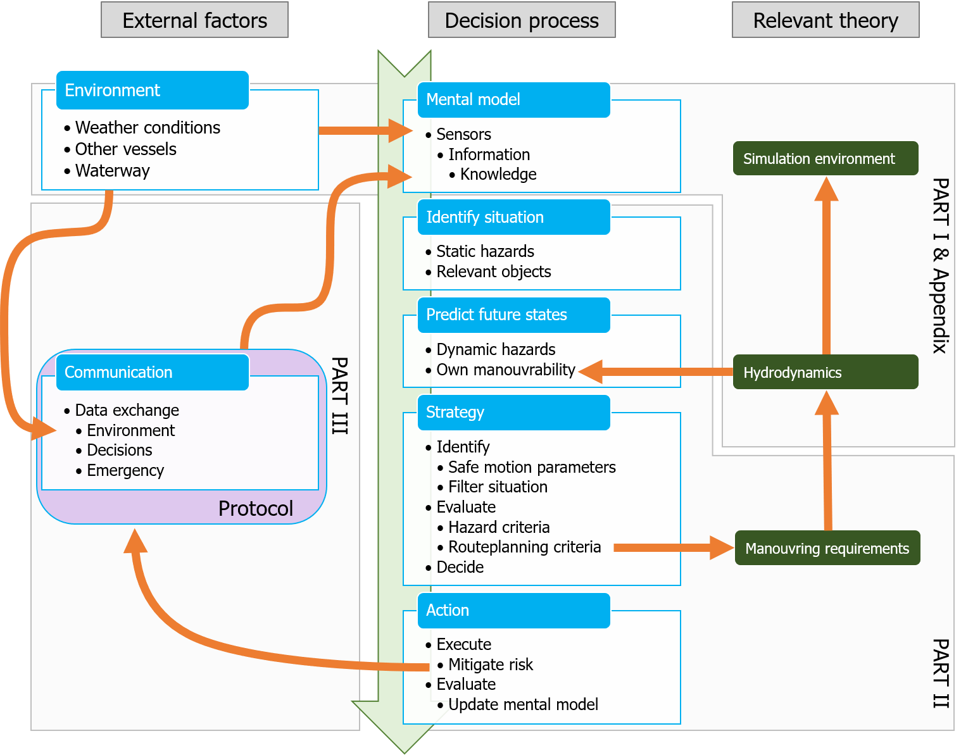

Figure 2.1: Decision model

* 1. *DECISION PROCESS* 19

form a correct mental model. For this research, only the result of this step is relevant: Is the acquired knowledge sufficient to identify the situation correctly, or is more information needed? Future technologies and sensors are not within the scope of this research, nor how their outputs can be combined into useful information.

#### Identify situation

The step from information to knowledge is in the phase where the situation, scenario, and hazards are identified. How this would go in practice is discussed in chapter 4. This step is taken to identify critical situations which should be evaluated during the design phase of an autonomous ship. This research will define a method to evaluate these critical situations. The situation and scenario are defined by the layout of the waterway, other nearby vessels, relevant regulations, etc.

#### Predict future states and decide on strategy

Based on the situation different strategies might be possible. These strategies have to be evaluated. This is done by predicting how the different strategies will influence the path of the different vessels. A trade-off must be made between exact calculations and computation time. For example is the closest point of approach (CPA) currently determined using linearized algorithms in common ARPA systems. Using non-linearized methods with for example a B´ezier curve will result in smaller errors. Simulations would improve this even more, however does a simulation with correct hydrodynamic models costs much more computational time. In chapter 5, the linearized and non-linearized methods are described. The simulation is done with the tool as described in appendix B, but this tool is not optimised for such calculations. Therefore these calculations cannot be done real-time. The hydrodynamic model used in the simulation is also described in appendix B.2.3. After this phase different manoeuvres are evaluated that correspond to the different strategies. How this will be done for common critical strategies is discussed in chapter 6, this will result in manoeuvring requirements, these requirements can be used by ship designers, to ensure that the ship can operate safely with minimal need for communication. After the evaluation of these criteria is known which strategy will result in safe operation of the vessel.

## External factors

How easy it is to go through the decision process and end up at the right strategy depends on the situation. The situation is mostly influenced by environmental factors. In some cases are the static sensors not sufficient to analyse the environment properly, resulting in an incomplete mental model. This section will describe in more detail how the environment influences the forming of the mental model and how safe operation within this environment would benefit from communication.

### Environment

The mental model is a representation of the environment in which the vessel acts. The sensors will measure this environment and provide the data. Many critical situations occurred due to weather conditions. The cause is that sight is limited during heavy rain or snow. Also might the wind and waves limit the manoeuvring capabilities of a vessel. This is also the reason that some vessels are not allowed to enter a port when winds are too high. This is mostly due to the layout of the waterway. Due to currents, operations (e.g. maintenance and fishery) or limited depth, might some area’s be restricted. This information is often acquired via communication channels, but communication channels which only allow receiving and not sending, such as Navigational text Messages (Navtex).

The same applies for basic information on other ships. They might send their location and speed via AIS, but still key is the ARPA. Due to weather conditions, these systems can be less accurate, as heavy rain creates noise at the radar. In the situations where sensors are not accurate as expected, communication is needed, even if the whole decision process itself is optimized to avoid communication. The same goes for communication with shore-based stations such as traffic controllers or in the future remote pilots. These often have information which could not be retrieved via sensors or current systems. Such as a place and time to berth or pick-up a pilot.

Both shore-based stations and ships can only share intentions and their planned path via the radio. Future unmanned will most likely be able to negotiate using other systems. But in case with manned-manned or manned-unmanned interaction is this only possible via VHF radio for now.

* 1. *EXTERNAL FACTORS* 21

### Communication

As described are there still cases in which communication is necessary. In part III a case where communication between manned and unmanned vessel is needed is discussed. Using the situated Cognitive Engineering (sCE) method a protocol is defined, based on existing systems and protocols. Thus using AIS to send written messages, or VHF and Standard Maritime Communication Phrases (SMCP) for verbal messages. Other cases such as communication with traffic controllers and pilots could use the same protocol. Although they might need to share more information with unmanned vessels, which could be done with a new system such as VHF Data Exchange System (VDES). This will however not be part of this research.